House Of Today Ministries, Inc
PO BOX 2524
Powder Springs, Ga. 30127

Ministerio Casa De Hoy, Hwy CA1 Comali, San Marcos De Colon
Depart. of Choluteca, Honduras, CA Hebrews 3 :13-15
Bethesda, Christian Community Church of Comali John 5

Sept 17th,2022

We greet you with blessings to all our friends, family, and supporters,

Our hope is that this note finds you all doing well. We realize that it’s been 7 months since our last writing. There are so many great things that have happened since everything opened for travel. After a long period of lockdowns and restrictions, we were able to go visit in Georgia during January and February. I also was able to attend a 3-day Women’s event with many of our old friends. That trip was a great blessing for me as it had been a long time since I had been able to fellowship and worship with many ladies in my own language. One of the hardest parts of being in another country where you are away from your family, your church and your friends is the need for fellowship, including music, Bible study and social encounters with fellow believers. We are the ones most often giving to the people, but we also need to be ministered to on a personal level. The lockdown for Covid 19 lasted here longer than it did in the USA and we still have some restrictions regarding mask and hand sanitizer in the public businesses. That stretch of time was very trying as we know so many experienced loss and illnesses here and all over the world. We are thankful for the technology advancements that allow us to have conversations and video calls. In the beginning of our time here that was still very limited. We have seen a lot of changes here in 7 years. Wow, 7 years! Currently we are in the process of acquiring our Permanent Residency Visa. Once completed we will no longer be under the Religious Visa that allowed us to stay for 5 years. The new Visa will allow us to travel back and forth on our time frame. This does not mean we are giving up our American Citizenship, it just means we are allowed to maintain our home here indefinitely. Please pray as the process is slow and has met delays due to the change in Presidency here Jan 21st. We do receive regular updates of our pending status. We also must pay a processing fee every 60 days that it is on hold. At this point we have decided to postpone our fall trip to Georgia. But we look forward to an extended time in April 2023. A portion of this trip will be furlough time to spend with our family. We have not been in Ga for Easter in 6 years. We would love opportunities to visit with groups, churches, or individuals in your home. We will be putting a calendar together after Christmas.

We receive messages, especially from those coming to visit asking “What does your ministry need?” First and foremost, we would like to say what we desire most is to see the lost coming to know Jesus and that we pray they will see Him through our actions.
Second, we are always in need of prayer for our health, those we minister to, safety and our families at home. A list of current financial or material needs will be in the closing portion.
We would like to say how important your love and prayers are for us and each one we encounter. When you say or write “hey I am, or we are praying for you” it really does help us in those difficult days. There are times we miss our family and our friends. One of the biggest encouragements comes when individuals or groups come to visit and stay here with us at Casa De Hoy. You can see first-hand the things that happen in our daily work as you participate in programs with our children, youth, and elderly. When you build relationships with the people one on one you experience blessings as well as give blessings. If you would like to consider joining us in 2023, we would be happy to discuss arrangements and options. You can email us directly at Jodytimp@gmail.com for information. You are not “required” to have a group leader. It is best to have at least 2 people to keep expenses for travel at a minimum. There are often times we can put a small group together with you and a couple of others. We have seen some great friendships because of this. Booking in advance gives you better flight fares and can keep your total trip to less than $1200 per person.
Our facilities are customary or typical Honduran, Casa De Hoy is a Ministry House. We have 3 bedrooms, 2 full, 1 half bath, a large sitting area, a screened patio between the rooms and a larger covered patio between the house and the church. Our rooms do have a variety of bunkbeds,1 king and 1 queen bed, due to the facility being group oriented. It sleeps 9 -11, with an average of 3 to 4 to a room. There is an additional space located in the church for folding beds if needed.

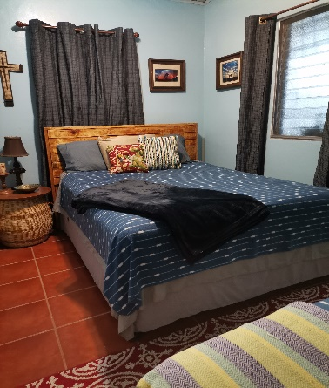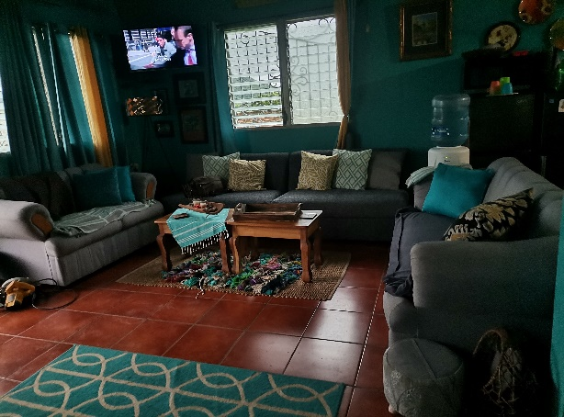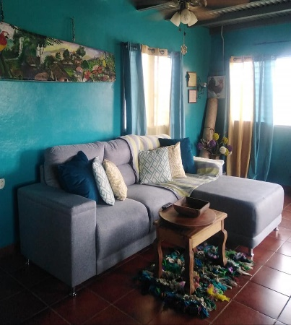

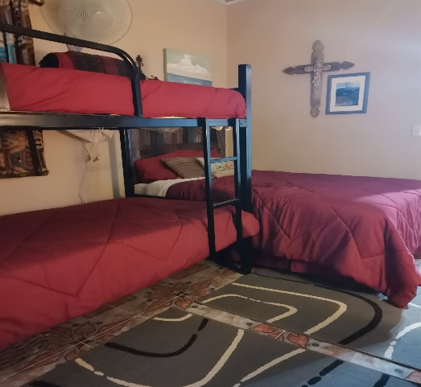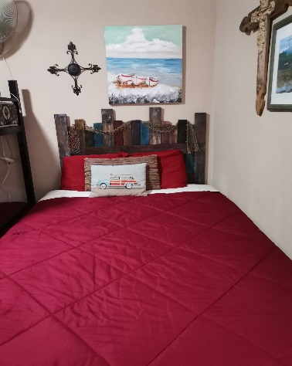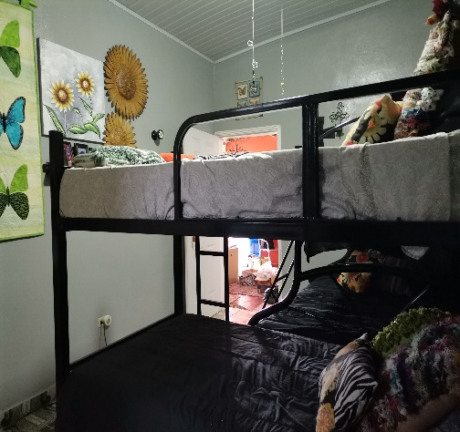

Church news: Our church services at Bethesda, Christian Community Church are at 3 pm. This is the best time for those in the community that need to attend to livestock or in some cases work a partial day or at night. The average attendance of adults is currently lower than usual at 40 to 50 due to the rainy season. During the better weather days, we have run 60 to 80. Most of our people walk or take a form of public transportation. Most of the public buses do not run after 4 pm. We have an additional 30 to 35 for children's service. Due to the rainy season many children do not attend regularly. This is due to transportation and the fact we cannot hold the children services outdoors if it’s raining. We are desperately in need of constructing one or two Sunday school rooms. We have an area adjacent to the church that runs directly behind the ministry house placing the back wall on the properly line. This would allow us to divide the children into 2 age groups and to give them a safe area, free from rain, as well as away from the traffic in the front of the property. Having a growth issue is a good issue. Many children here do not attend church with family but will come to all the events, programs, and services. Giving us a large opportunity to reach them with the gospel. Reaching them brings interest to the adults of our community. We have had an increase in adults that attend special events with children. Because as one lady told us, she “came to see what we were about, her children talked about us all the time”.
Fatima, Pastor Denis’s wife is a bilingual teacher. She works with the children on Sundays. She has a lot of great ideas and a heart to serve the children. It is important for us to provide the resources needed to help teach the children God’s word effectively. We do need to find an additional teacher to help in the event Fatima is out. Please pray that we can find someone to assist her. Most of the ladies attending our services are either unchurched or not saved. We need a lady with like mindedness who is strong in her faith and knowledge to help in this area. The children love Fatima. They are so eager to learn the word, the lessons, and the songs. She not only teaches them songs in English, but she will also explain what words are so they know what they are singing about. She is very interactive with them. Personally, I can’t even imagine trying to teach the large number she works with in such a variety of ages.

Our teen program is going through a transition period. This is a time where we really need prayer for this age group. Various situations from bullying to personal disagreements among them brought on a time of recess. Having a group of 50 to 54 in attendance, not including our college volunteers that help with youth activities met with some difficulties. Even teachers in our area were asking Tim to come and meet or talk with students. Many parents have complimented us on all our efforts and pray for us. Truthfully, we feel this is a result of them having no classroom attendance for over 2 years. Social skills have been challenged as well as loss of family members, some being forced to move, financial stress, lack of food in the home and the growth of the group. Currently we are working on a restructure where the group will be limited to those that have a true desire for bible study, like a youth Sunday school class. From this we will start to increase by encouraging them on ways to reach their peers. By learning to invest and invite others back into the group.
We have 2 college students now, however in December post the November graduation that will increase to 7. Therefore, we will be working on a program that will allow them to learn and possibly teach in the youth classes.

Our average offering is approximately $10 to $15. These funds are used to help with cleaning/bathroom supplies and transportation cost of our primary musicians who live further from the community.
The financial support for our pastor usually comes from our general budget. If you have interest in offsetting that amount you may make donations indicating Pastor Expenses / Bethesda. Currently due to our general budget not being able to meet this need, we are personally giving to his support. As a ministry we do not have our Pastor work solely on donation support but offer him an agreeable amount so that we insure he is cared for the way we feel God intends.
Pastor Denis has an older model truck for his personal transportation as well as for his metal fabrication business. Last year we were able to replace his bald tires with new ones. Currently the aging truck has had multiple issues that needed or still need repair. He has been faithful to the church. He has even had a relative loan him a motorcycle in the rain so he could make it here to preach. If the Lord should lead someone to give funds to assist him in these repairs or to even purchase a newer model truck, it would be a great blessing to him and others. We are pleased that at the beginning of January 2022 we came into agreement with Pastor Denis and his family to continue with us in the journey to win the lost and disciple the people of Comali. We also reach to the surrounding areas with families from Trapiche, Barranquilla and San Francisco. We have been blessed to have others in our area attend to sing and lead music. We are thankful for the outpouring of those that have found interest in the ministry.

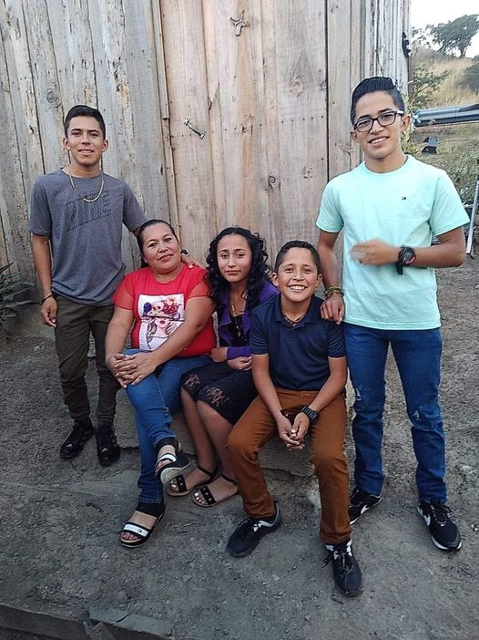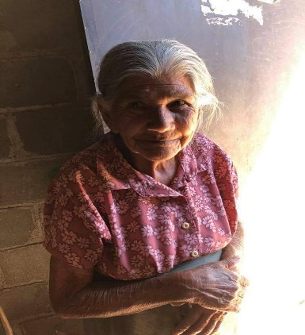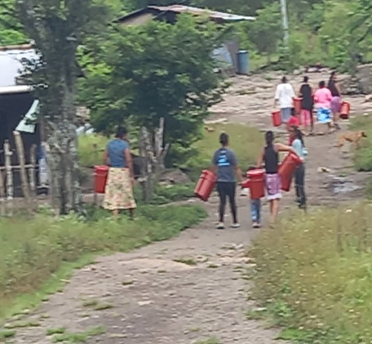

Giving aid to families, children, and elderly is at the core of what we do.
This year we have had 2 professions of faith and 3 reconciliations of faith.

Their visit means so much:

Each year we are blessed by the visit of a couple from our board who have stayed with us since day one. They have held us up, helped us through the good and bad, made airport runs, provided transportation, scheduled meetings for us and so much more. Tyler and Amanda Jones recently came with a team from Mercy Hill of Marietta, Ga. It was a true blessing, and we experienced some great times. We were blown away by the outpouring of their church members sending 3 suitcases of various supplies we needed from cleaning supplies like Magic Erasers, school supplies, books, seasonings we can’t get here, Country Time lemonade and the Blue Kool Aid the kids like here, personal gifts from family and friends, just so many blessings.
Our teams participate in the preparation of food bags for the community, meals for the elderly served here each week, sharing devotions, serving kids, playing games, making, and giving out candy bags, distributing Bibles, well the list can go on… below is a note from Julie. It was her first time here, along with her 7 yr. old son.

My seven year old son and I served through House Of Today Ministries at Casa De Hoy. Tim and Jody offer lovely accommodations and clearly are serving with a godly- heart. We both practiced speaking Spanish though we could have had a successful trip without knowing the language. We packed about 150 food bags to deliver throughout the community. We also served on the property during the teen service and the senior citizen service. We sang our lungs out for the Lord. Best of all was the kids service/ day. My son played baseball and soccer with all his new Honduran friends. After church we did an art project and seeing the pride of the children in their creation was heart warming. We started some meaningful and likely lifelong relationships. Bible study in the evening helped our group connect amongst ourselves and with God. A hot shower daily and delicious meals were an added bonus. We pray daily for the work that Casa de Hoy is doing and look forward to our return to Honduras.
Julie Krause Riggs
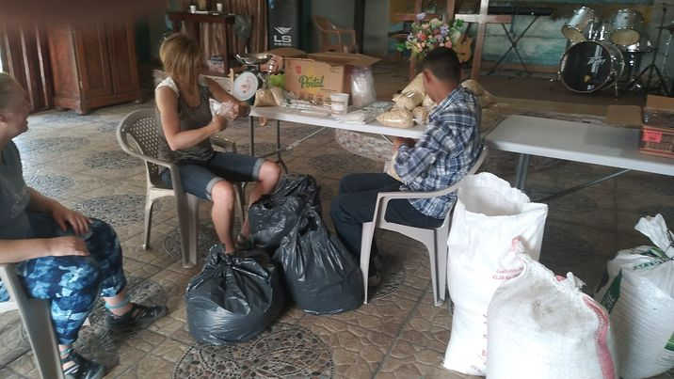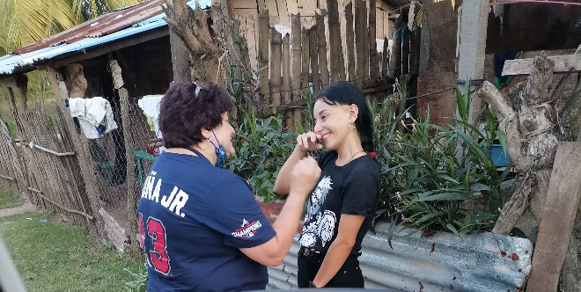

It was also a great blessing to have a brief visit from friends we previously served with back in our days of doing Medical Missions. That was the beginning of God preparing us for this ministry. Thankful to all those that came to enjoy Sunday lunch and a service held here in Bethesda. We are thankful to Mercy Hill and Oyster Bay Baptist for their generous donations that allowed us to feed the people attending church a hot meal. 136 people went home with a container of Chicken and rice prepared by our cooks Chena and Bessie. It also allowed us to distribute over 150 food bags to the communities and village areas we serve. This was a huge blessing to our people.

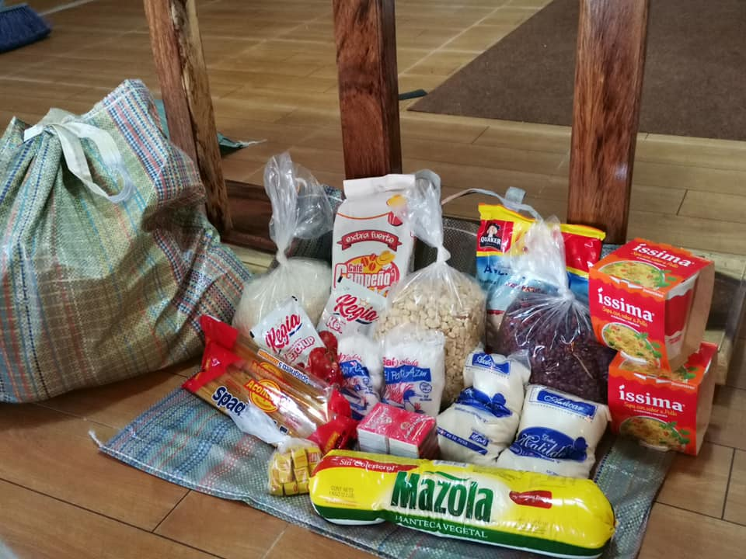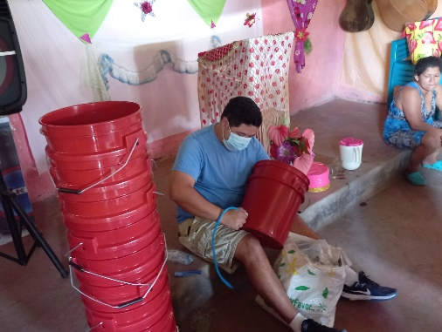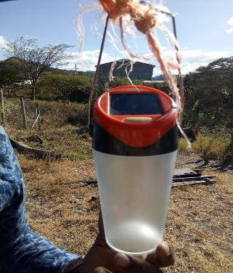

Water filters, Buckets, Solar lights, Food bags and Bibles:

We were introduced to water filters in 2012 by a guy from Alabama that we met on a mission team with a couple of combined groups. Later we were introduced to solar lights, a little larger than a small flashlight by our friends Lowell and Nadine Huffman. Both became part of our life sustainable project goals. We have developed ways to use these to assist many and share the Gospel personally when providing them in a group setting or individually. God has opened many doors for us to provide these items and plant seeds of hope in the process. When teams are coming, they often ask what they can bring or what projects they can do. These are some of the item’s we tell them to bring. We purchase the filters from Filter Of Hope, an organization in Alabama and have them shipped to the team coming to pack in their suitcases. Sometimes the team’s leader or church will purchase these themselves to bring. We do the same with Solar- lights from another organization. Both lead in providing to missionary’s quality items. We started out purchasing 2 buckets and lids for each filter but about 2 years ago another leader from a similar filter program shared a video with me. From that we started purchasing 35 to 55-gallon plastic drums. Along with one 5-gallon bucket for each family. After we had presented drums to a couple of locations, we learned that placing them on a wooden structure was not stable. Currently we build a metal frame that holds the drum securely, this allows us to install 3 filters to the barrel. It is important to purchase new unused barrels with a removal latching lid. This helps in installation of filters, cleaning and keeping the insect or mosquitoes out. We designate a person of contact to be in charge of the barrel system and they work with families and a local pastor if available to care and assign days of access. This gives a great opportunity for village pastors to spend time with the people of the community. In the case of elderly people that are not able to get to the barrel area we still provide a bucket with individual filter at their home. Some will catch rainwater to filter. The metal frame is built by a local neighbor. This gives an opportunity for helping him have income.
The cost of the frame materials and labor, barrel, and 50 buckets with lids for a village is approximately $390 depending on vendor pricing. This does not include filter cost. ($40 each)
These filters if properly installed and cared for can last up to 10 years. They provide purified drinking water to help family avoid parasites and other health issues. Many of the people here get their water from rivers, rain or a pila (a concrete water source that is unclean).

Tim, Adiel, Carlos, and Bryan have just made the trip to Oyoto to set up a barrel system. They also distributed Bibles and candy for the kids. This is a community of 47 close knit families. The access is a one lane road barely wide enough for a pickup truck. The people there are welcoming and thankful for our efforts to assist the families and children of their small school.

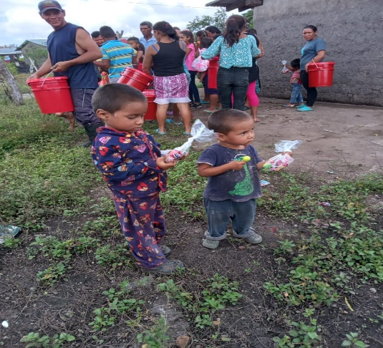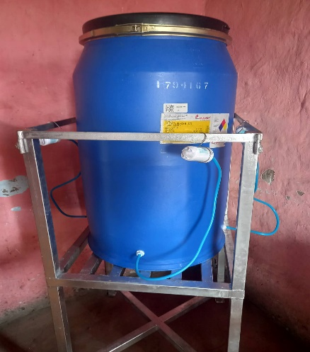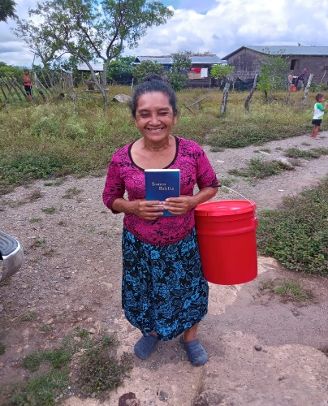
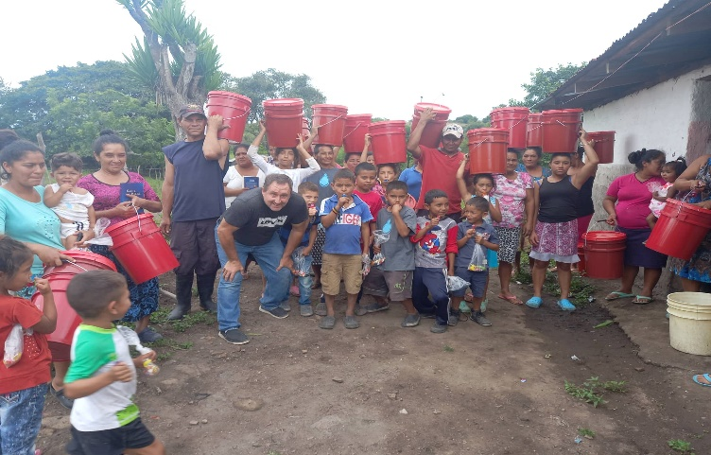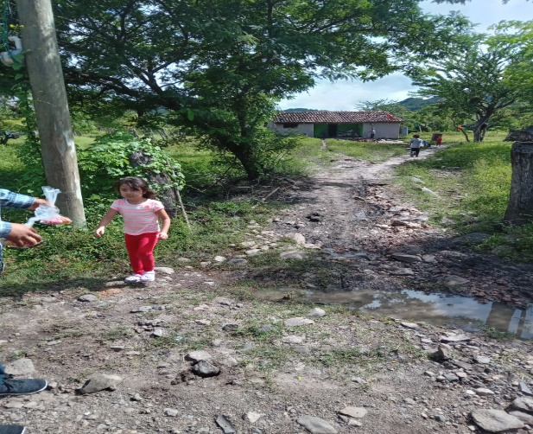

We are grateful to Oyster Bay Baptist Church of Gulf Shores, Ala. for providing a recent donation of filters and funds to make several of these projects possible.

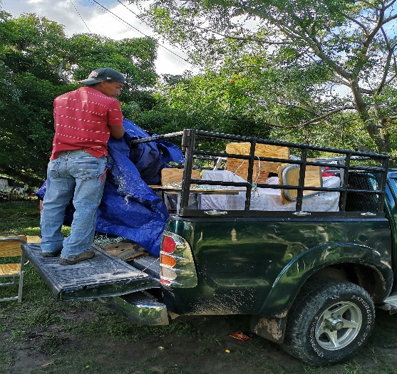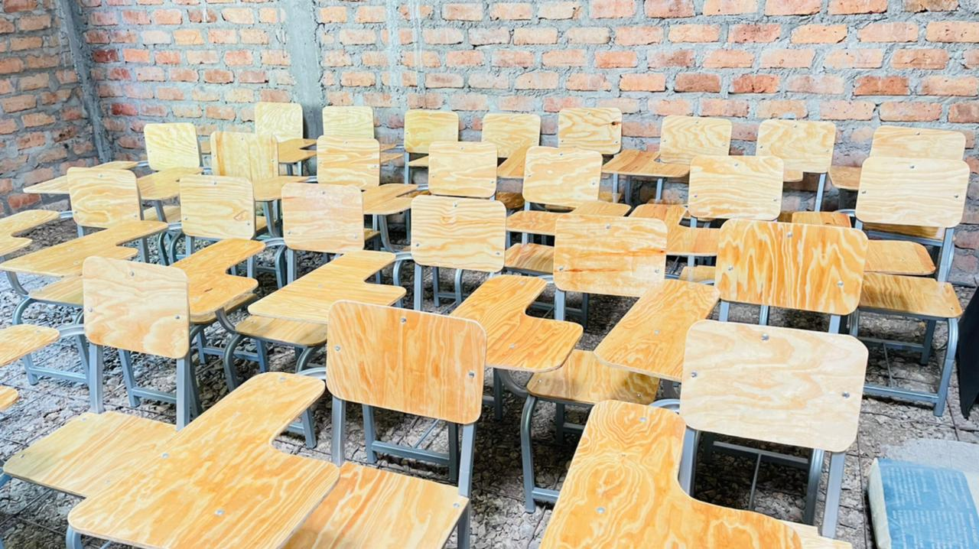

School desks for Los Mangos:
Our newest board member, Brandon Roberts came on this year in July. He is currently a schoolteacher in Georgia and attends First Baptist Woodstock Church.

After cancelling his trips due to lockdown several times, he was able to visit in February 2022. He immediately went into action organizing getting school supplies here just weeks before the children returned to school for the first time in over 2 years. One of the schools we assist is in Los Mangos. The teacher there presented us with a letter regarding the need for 47 new school desks. This is a 2-room school with 2 teachers. During lockdown the desks had been damaged from termites. Brandon organized fund raising to help us deliver the first 23 desks. Currently we have raised almost 2/3rds of the funds to get the last desks made. School ends here in November. If you’d like to give to this project each desk is approximately $68, They are made of metal framing along with a treated wood that was special ordered.
Brandon will be returning in Feb 2023 with more school supplies.
If you are interested in information on this trip, you can email us.

BUILDING HOMES FOR THE NEEDY:
In 2018 we started our first project to build a home for a family living in a unlivable wooden house with dirt floors and a leaking roof. It was ready to collapse. Since that time, we have built various homes, in different areas of Honduras. Recently the gentleman that received that block home he referred to as his “PALACIO”. went home to be with the Lord. Papa Gonzalo was whole and now in his mansion.
Construction teams to assist single parent homes, homes for elderly or disabled are a great way for church groups to bond on the field with their team and the family receiving the home.
To date we have built, repaired, or added additions to over 50 homes. Tim and Alfredo have recently assisted a family with construction of foundation, walls, and flooring for a home for a young lady that will graduate high school in November.
.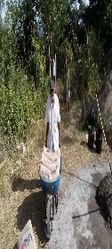

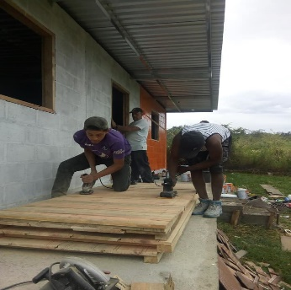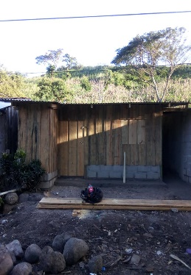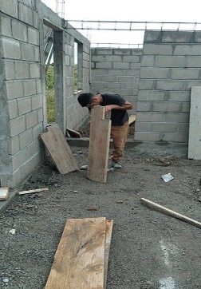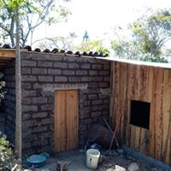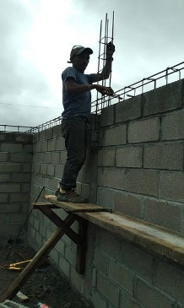
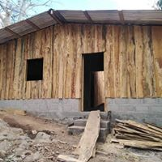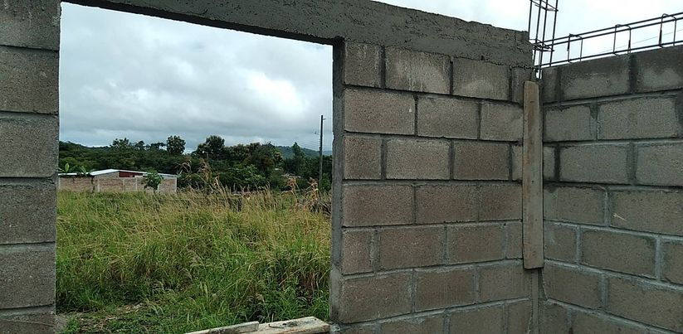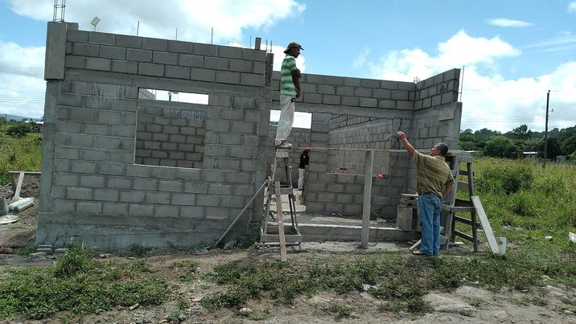

.
A few pictures from our Sept. 10^{th “} Día De Nino” (day of the children) celebration. A yearly event that honors children with a party, traditionally giving small gifts, a meal and lots of candy! This year we served chicken legs with fries, ice cream cones and blue lemonade. We were able to give out 26 door prizes that were educationally oriented. There were 2 large piñatas, games, singing and a lesson on Fruits of the Spirit and the 5 attitudes to use applying those spiritual fruits to your life. Carlos and several others helped in leading the program. We are thankful for those that gave to this event.

Education is a huge part of what we do to help these children develop a better lifestyle and to set goals for their future. We believe this will help them become the change in their families, community, country, and the church.

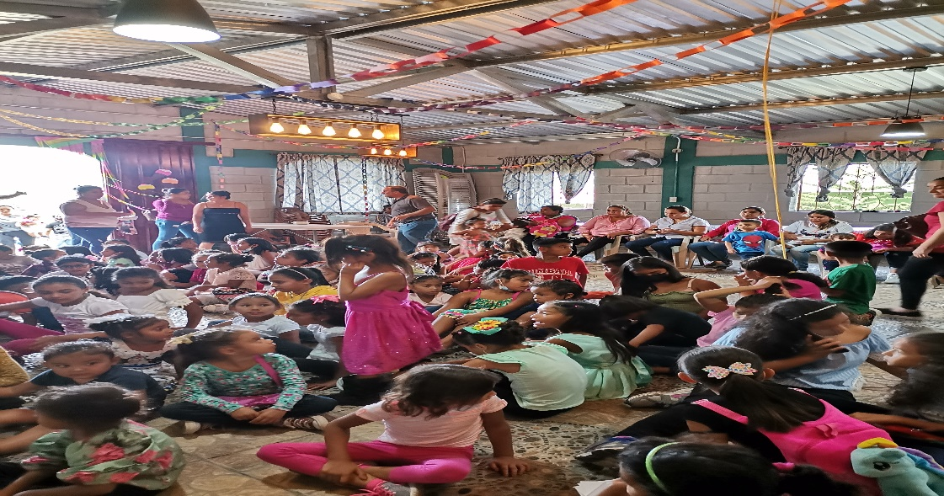

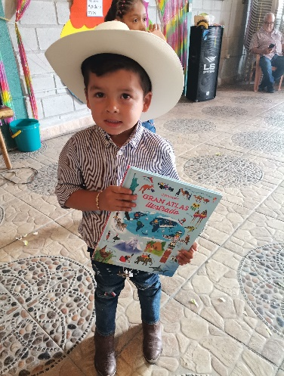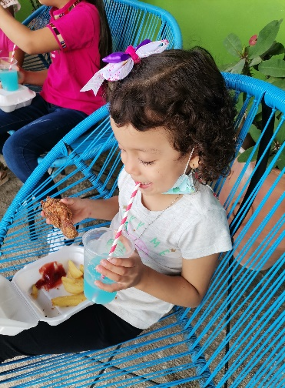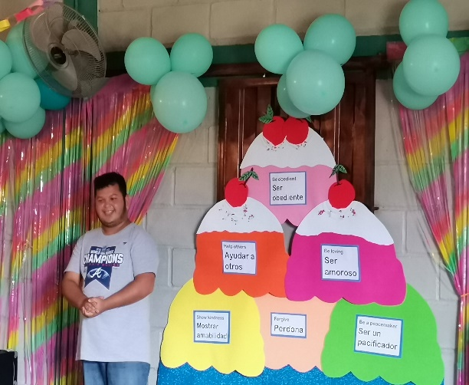

JOIN US FOR CHRISTMAS Dec 20th ! We have someone coming for 2 weeks and it would be a great way to share the holidays
giving to the children, teens, and the community.

OUTREACH and going beyond the walls: “The church is not the building, it’s the people”

I can tell you many ways to go out and reach people and I can invite you repeatedly to come here to Honduras to experience what it’s like. Each person has his or her own purpose and calling. Some people never reach forward to experience it, some do. Some people cannot physically go, but they can pray, and they can give. Many people have said “I don’t have a lot to give”. Neither did the widow, but she gave her all. One gave the oil from her alabaster box. There are countless examples of people who gave throughout the Bible and through history. Some gave of themselves, some gave of their time or talent, and some gave from their pocket, empty or full. There are many that give in private, and you never know of it, but one day …

Last week on Sept 10th it was the day of the children. Día De Nino’s is a traditional day every September to honor all children. We expected at least 200 plus, however rain is a factor too much lately. Our budget was pushed to it’s limits lately with so many unexpected issues, a broken washing machine in July, car repairs, roof issues, a refrigerator down/shorted out from electrical outages and a large entrance gate that broke from its hinges. The concrete column cracked after multiple rains and ground shifts. I was readjusting from Plan A to Plan B and maybe even Plan C.
I was reminded that we go through times when we struggle with “what if we can’t afford it”. I posted the need on Facebook, and it was met in less than an hour, Just the same as in July when I posted the roof was leaking and the amount was met in less than an hour. And the new metal roof was on before dark. God is faithful, even when we don’t think we can manage, even when we don’t see the how or the who. But it happens when people are obedient to His nudging. It happens when they reach deep to give their last $1, $5, or $20. It happens when they give that tax refund or bonus check. It happens when they tithe off the profits of the sale of their home or business. It happens when people are the church outside the walls of a building.

Needs List
- The approximate cost to build 2 Sunday school rooms is $8000 for basic building, not including furniture
- We need additional children's chairs which is $75 for 12. That number will increase once we complete the classrooms.
- A new refrigerator/freezer. Ranging from $800 - $1000
- Repair or replace washer $250-450
- Completion of our security wall $5000
- Christmas party for the community kids, includes a food bag., Last year we provided for over 300 children. The cost of a gift, food bag with a whole chicken, a meal, candy ,, games and a new bath towel for each child was near $6000, approx. $20 each *This year we would like to give each child a small blanket. Which I have a current price of $4.80 each if we purchase 300 minimum.

You can privately message or email me, if you provide a US phone number, I can call you to answer questions if necessary.
We greatly appreciate all the love, prayers and support shown to this ministry and us. Without each of you we would not be able to carry out the task God has placed before us.

Tim Preston , President, COO Jody T, Preston , Exc.VP, Director Casa De Hoy

